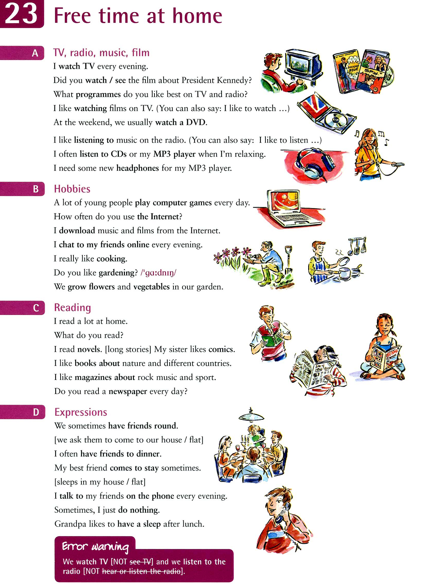
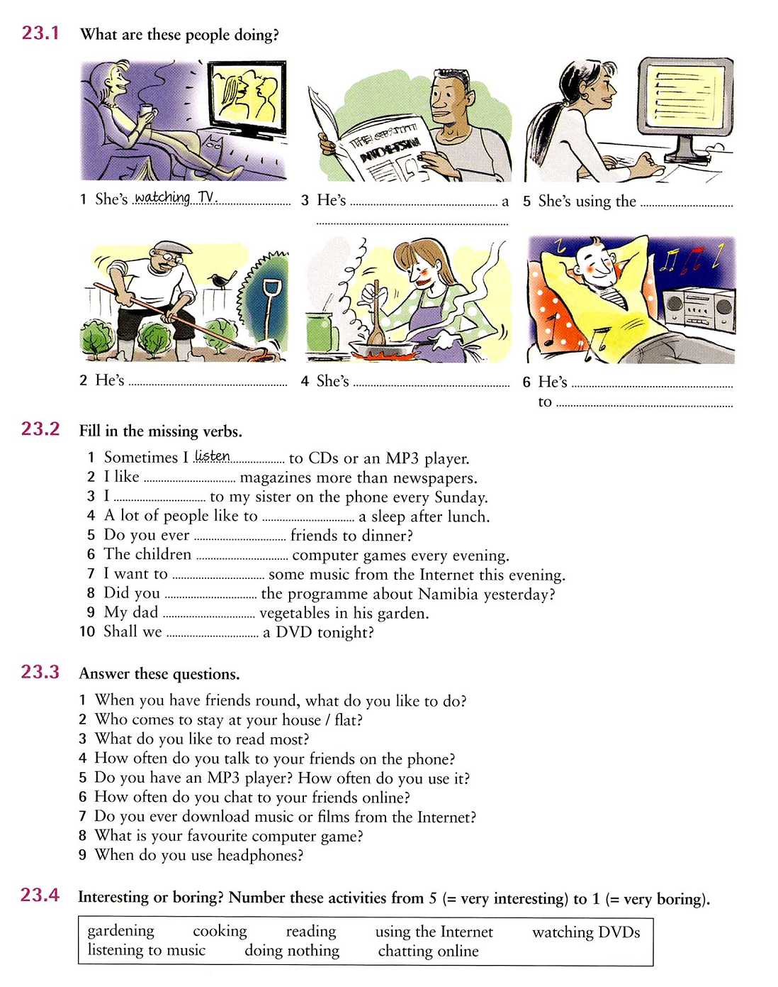

KEYS
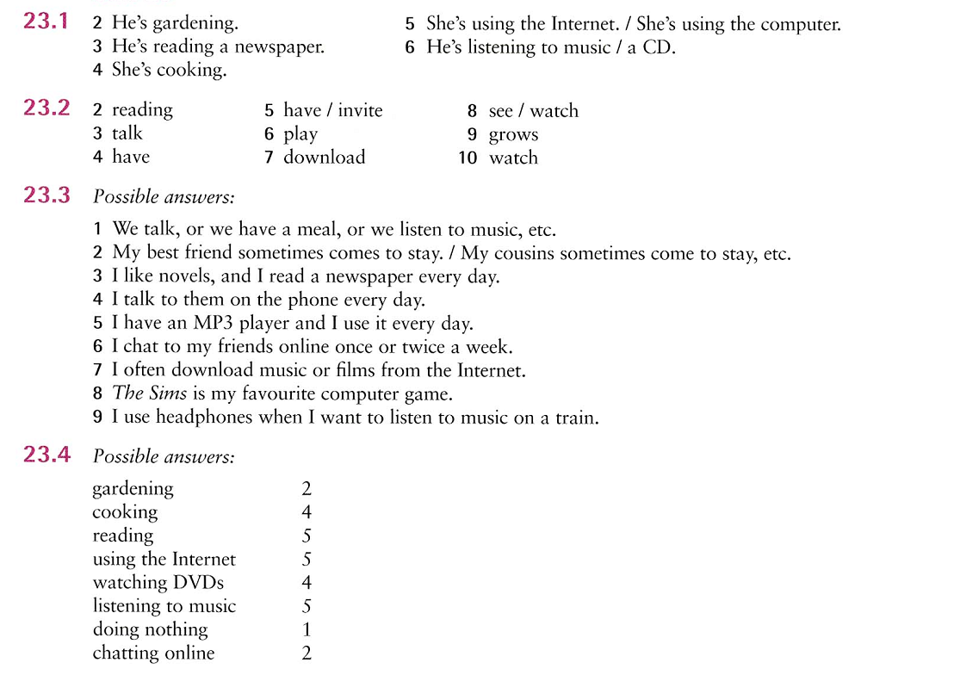

SOURCE:
McCarthy, M., & O’Dell, F. (2010). English Vocabulary in Use Elementary. Cambridge University Press.

